**Task – 4**

**Task description:** Create 2 VPC and subnets in each along with VM’s in 2 different regions and try to ping the VM’s.

* I did this task in AWS console.
* Select 2 regions. I selected my regions as:

Region 1: US east (N. Virginia) – us east – 1

Region 2: US west (Oregon) – us west -2

* For every region, I created VPC and EC2 instance.
* In that VPC’s, edit subnets, route table, Internet gateways.

🡪This is my region 1 VPC.

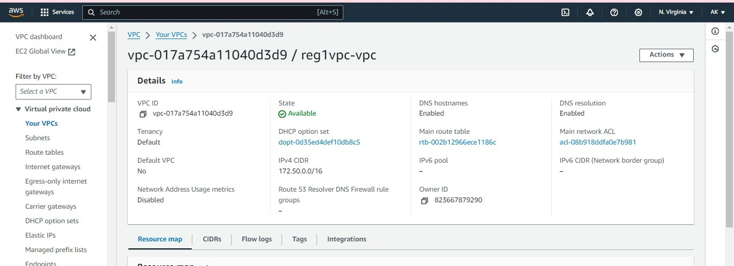

🡪This is my region 2 VPC.

TIM

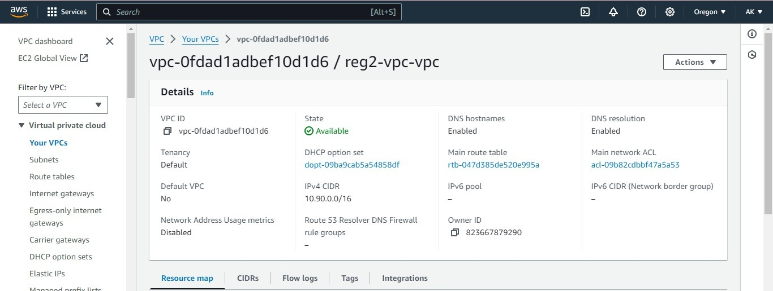

🡪this is my region 1 EC2 instance.

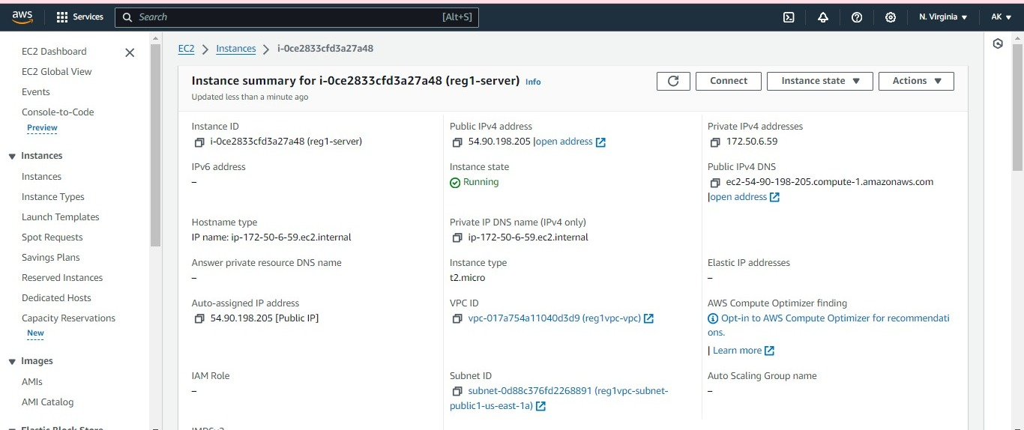

🡪this is my region 2 EC2 instance.

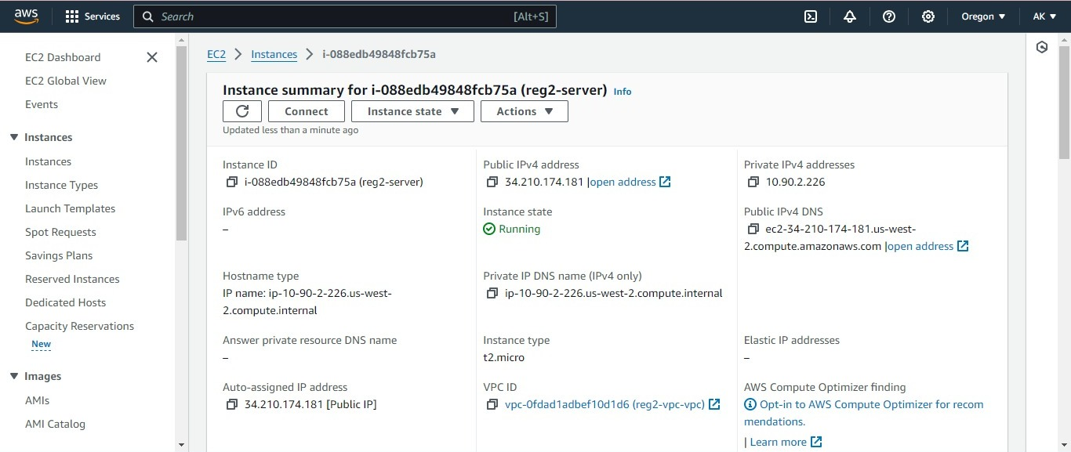

🡪Now connect the instance of region 1 using “task4-1” key pair in git bash and copy the url in ssh client.

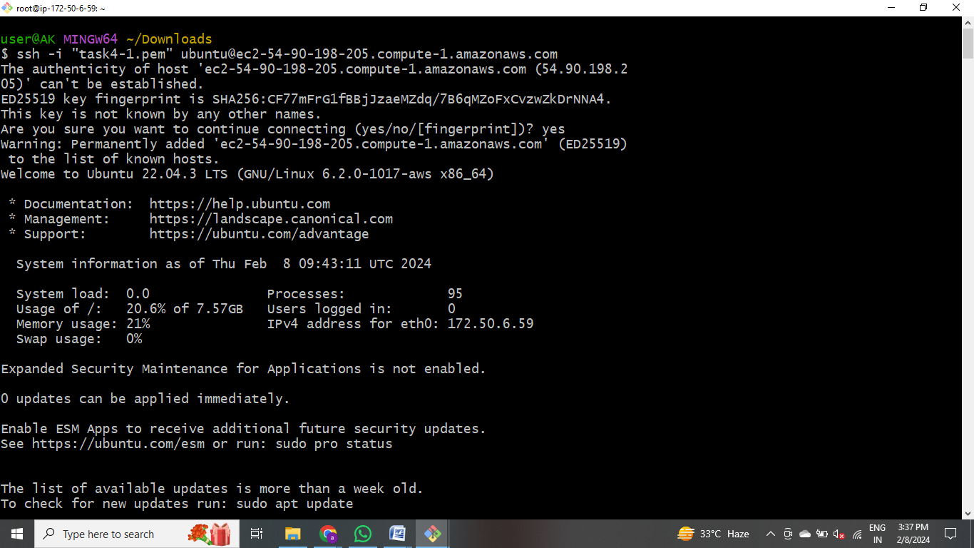

🡪 Connect the instance of region 2 using “reg2” key pair in git bash and copy the url in ssh client.

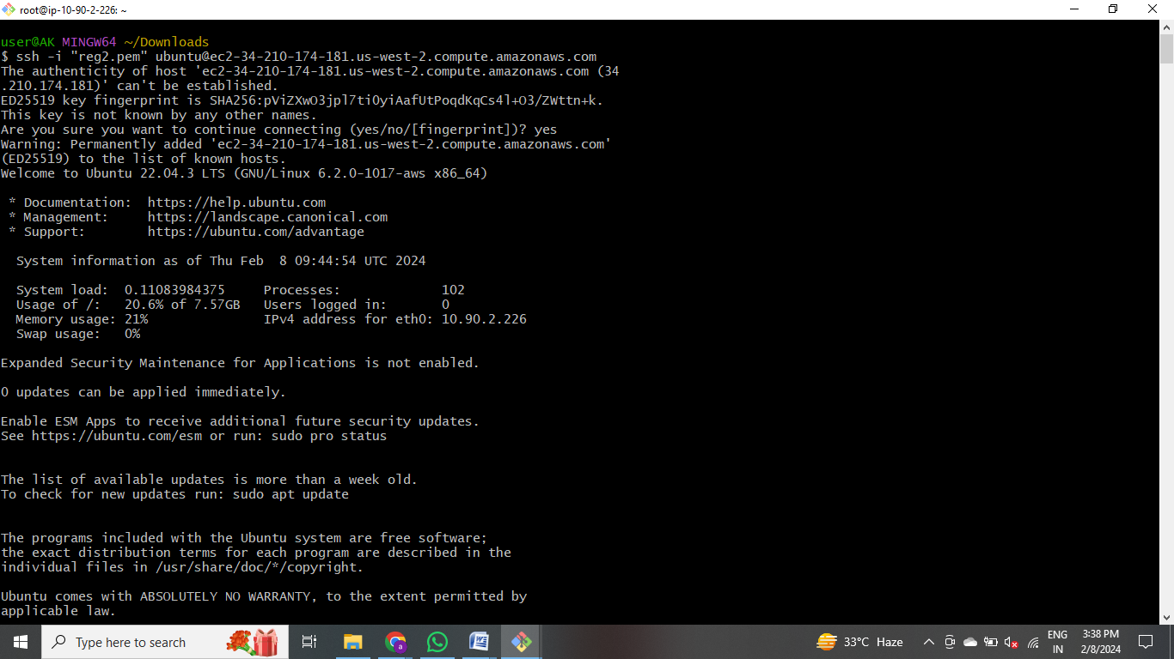

* + - In region 1, I created peering connection. In that we have requestor and acceptor. Requestor is my region 1 VPC ID and acceptor is the region 2 VPC ID (copy and paste VPC ID from region 2). After peering, go to region 2 to accept the VPC peering connection request from my Region 1 and accept the request.

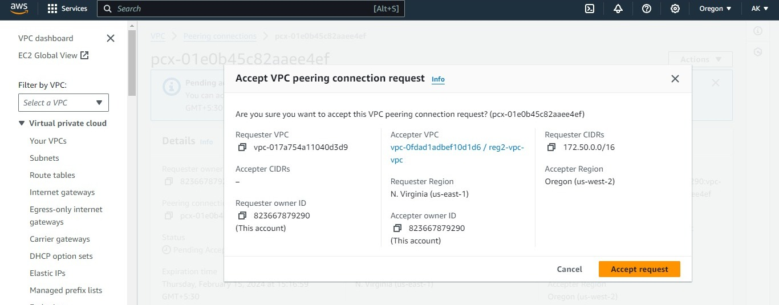

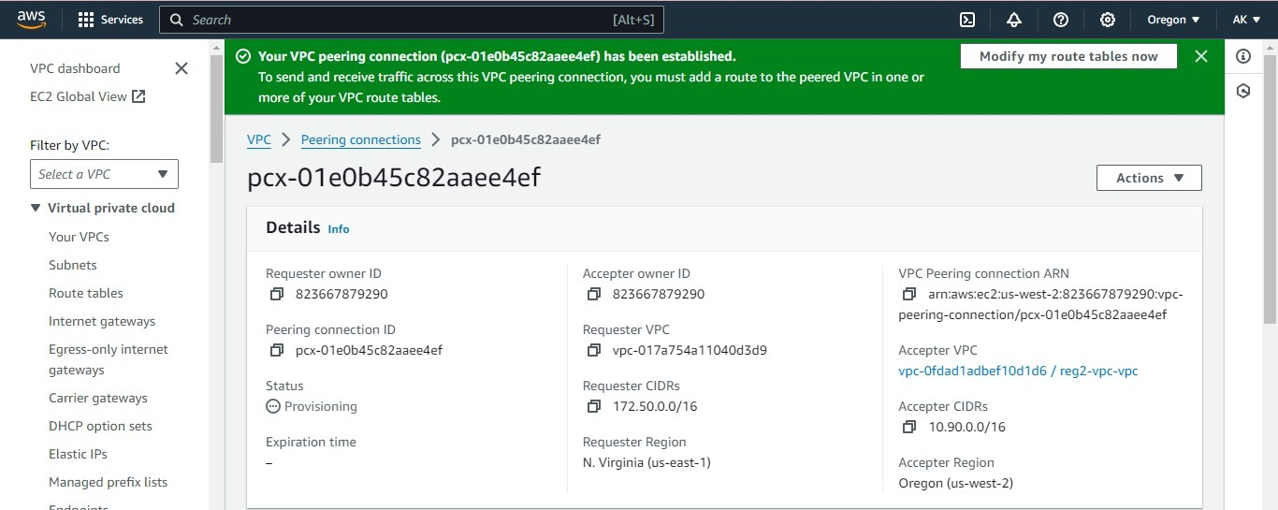

🡪Now modify the routes and add route i.e., region 2 VPC ID and peering connection in region 1. And it will automatically add to the subnets .

🡪In the same way modify the route for region 2.

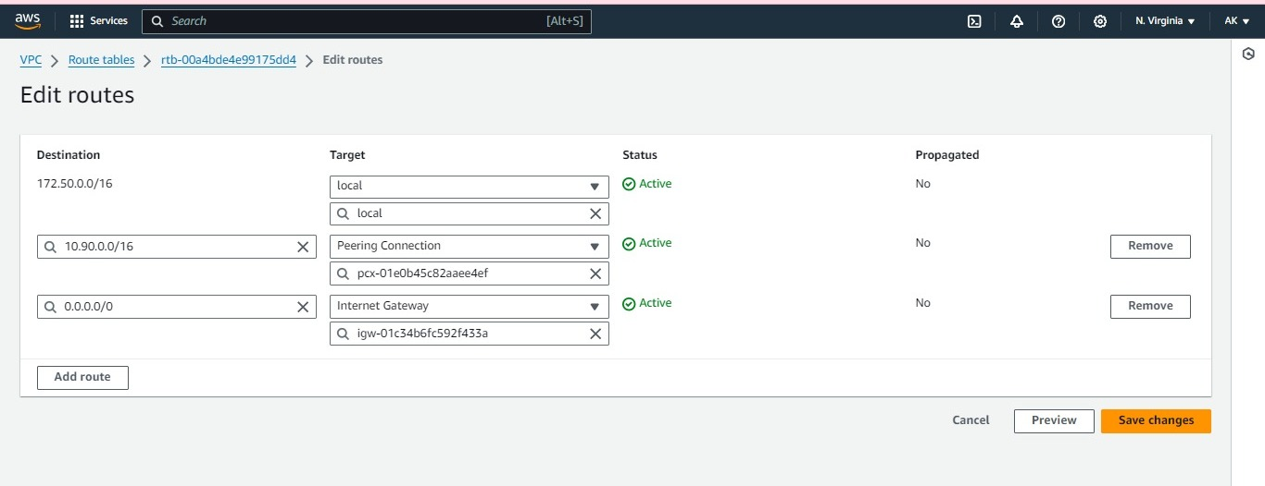

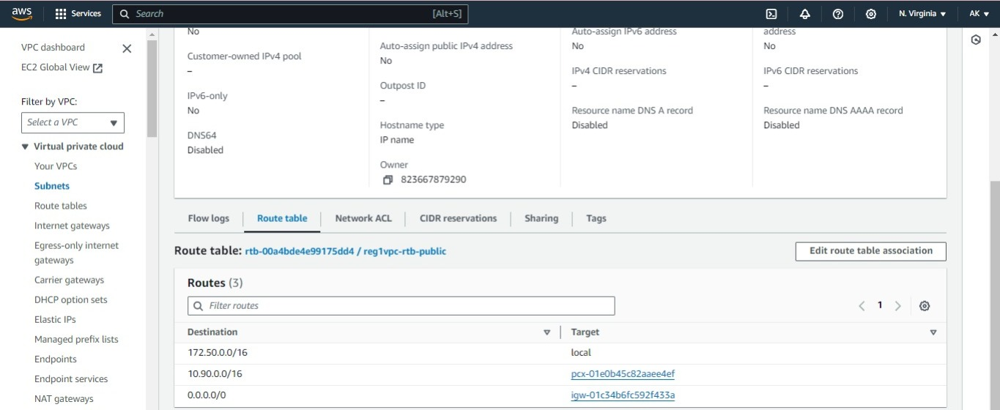

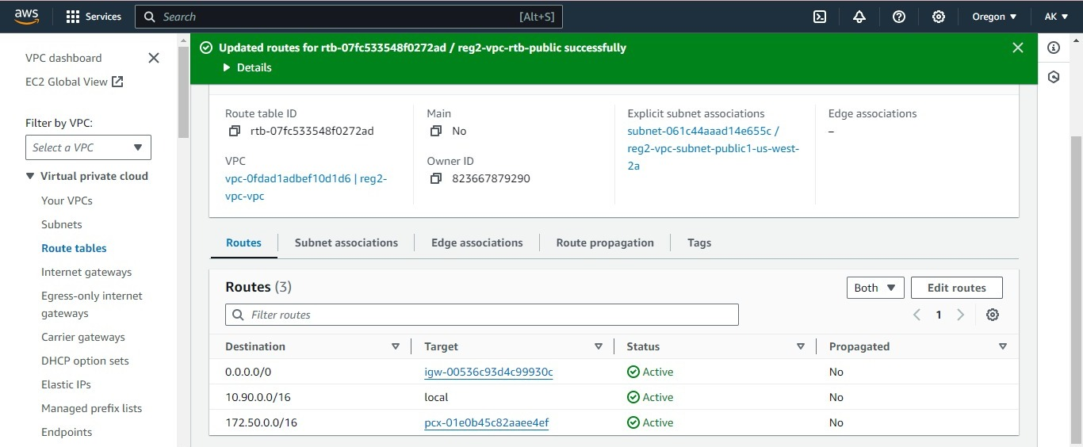

🡪Now ping the IP address instance of region 2 in region 1bash.

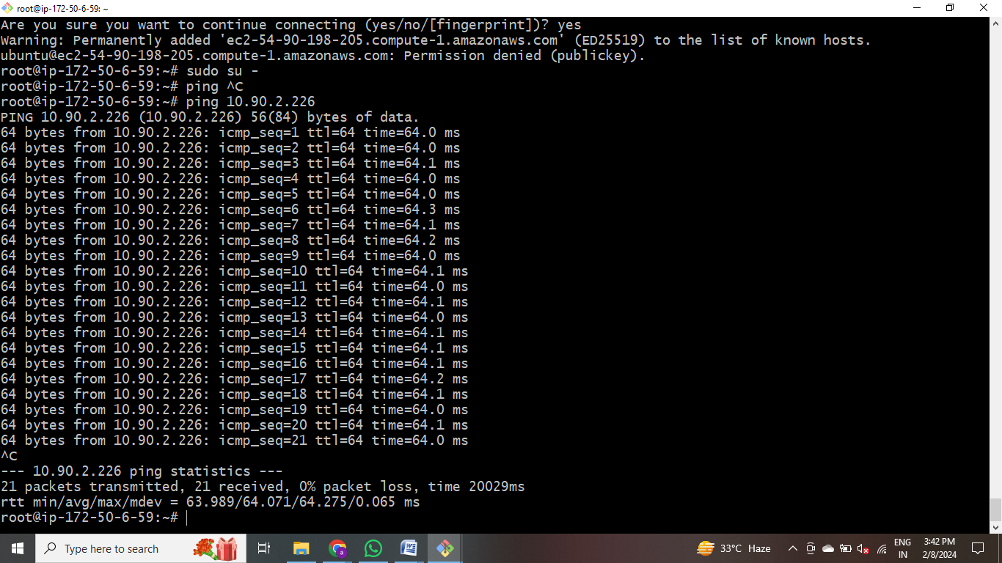

🡪 Now ping the IP address instance of region 1 in region 2 bash.s

